 **Project Design Phase**

**Problem – Solution Fit Template**

**Project Design Phase :**

**Problem – Solution Fit Template :**

|  |  |
| --- | --- |
| Date | 27 June 2025 |
| Team ID | LTVIP2025TMID59552 |
| Project Name | HealthAI-Intelligent Healthcare Assistant Using IBM Granite |
| Maximum Marks | 4 Marks |

**Problem – Solution Fit Template :** HealthAI solves a frequent and urgent

problem: lack of easy access to valid healthcare information and insights. It taps into the existing behavior of users searching for medical information online and replaces it with a credible, AI-powered platform.

**Purpose :**

* ✅ Solve complex health-related problems using intelligent and accessible AI assistance
* ✅ Increase solution adoption by reflecting how users already seek medical information online
* ✅ Improve communication using conversational chat and visual analytics
* ✅ Build user trust with consistent, evidence-based responses
* 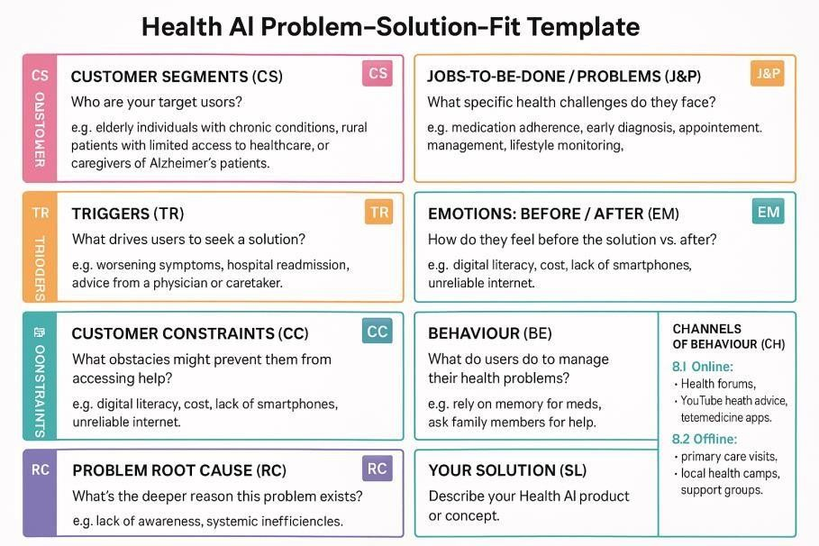



**References :**

1. <https://www.ideahackers.network/problem-solution-fit-canvas/>
2. <https://medium.com/@epicantus/problem-solution-fit-canvas-aa3dd59cb4fe>